AI-powered FAQ and customer support automation

INTRODUCTION
Project Title: AI FAQ ASSISTANT
Team ID: SWTID-2026-2400
Team Leader:
NAME | MAIL ID
Anok K | anokanokk51@gmail.com

Team Members:
NAME | MAIL ID
Dilli Babu R | dilli0052@gmail.com
Sathish P | satzisathish05@gmail.com
Mahesh T | maheshsivagami0402@gmail.com

1.Project Overview:
1.1 Purpose:
The AI FAQ Assistant is a backend-focused web application developed using Node.js, Express.js, and MongoDB, designed to provide a secure and scalable solution for managing question data through RESTful APIs. The system enables users to create accounts, log in securely, and access protected routes using JWT-based authentication, ensuring that only authorized users can perform operations. It supports complete CRUD functionality, allowing users to add new questions, view their faq assistant, update question details such as price or quantity, and delete items when needed.

1.2 Key Objectives:
- Provide secure JWT-based user authentication and authorization for protected API access.
- Enable efficient AI FAQ Assistantthrough RESTful CRUD operations.
- Ensure user-specific data isolation so each user can manage only their own questions.
- Implement scalable backend architecture using Node.js, Express.js, and MongoDB.
- Deliver fast and reliable API responses with proper validation and error handling.

1.3 Target Audience:
- Customers & Users – Get quick answers to frequently asked questions.
- Students – Find information about courses, assignments, fees, and college services.
- Employees – Get answers about company policies, HR procedures, and internal processes.
- Businesses & Organizations – Automate customer support and reduce repetitive queries.
- Website Visitors – Quickly find information about questions, services, pricing, and policies.
- Support Teams – Reduce the workload of customer-service staff by handling common questions automatically.
- Administrators – Manage, add, update, and organize FAQ content.

2. PROJECT ARCHITECTURE

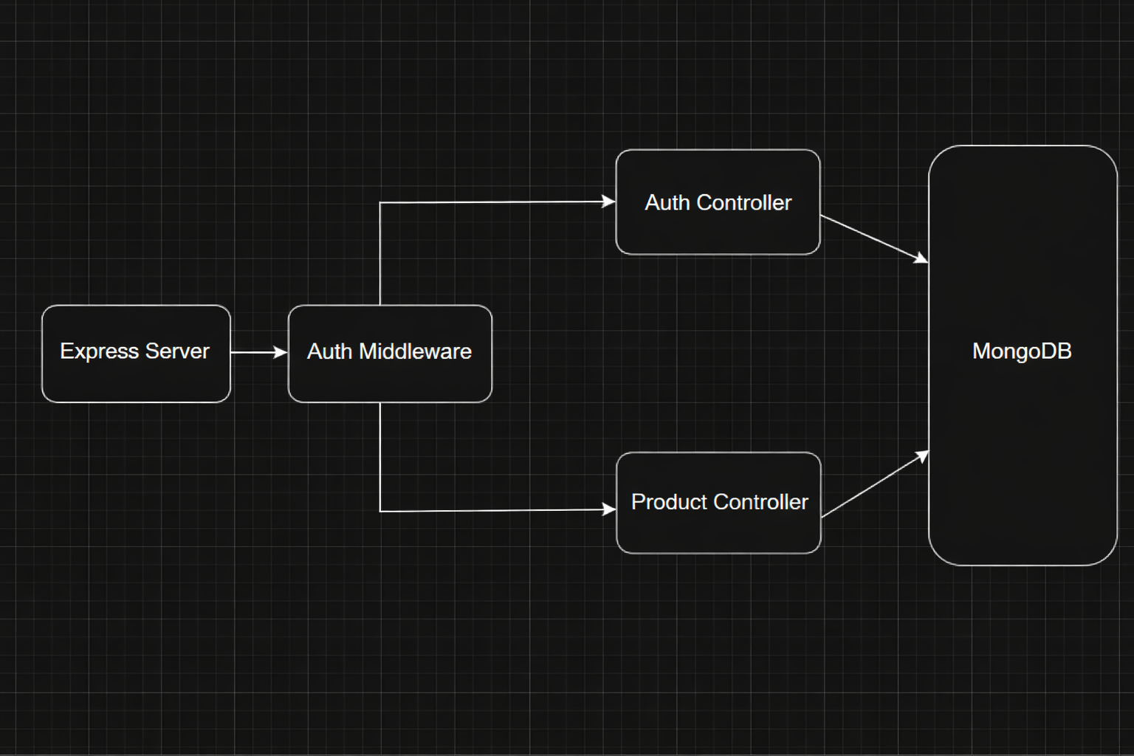

2.1.Express Server :
In this AI FAQ Assistantproject, the Express Server acts as the main backend server that receives all requests from the frontend or API tools like Postman. It manages the routing of requests such as login, question creation, and question retrieval. The server organizes the application structure and connects different components of the system. It forwards incoming requests to the authentication middleware for security checks. This makes the Express server the central point that controls the application flow.
2.2.Auth Middleware:
In this project, the Auth Middleware is used to protect the faq assistant system from unauthorized access. Whenever a user tries to perform an action like adding or updating a question, the middleware checks whether the user is authenticated. It verifies the login token before allowing access to the system’s resources. If the authentication is valid, the request proceeds to the controller; otherwise, access is denied. This ensures that only authorized users can manage the question faq assistant.

2.3.Auth Controller:
The Auth Controller in this project handles all user authentication processes such as registration and login. When a user enters login credentials, the controller validates the information with the database. If the credentials are correct, it generates a token that allows the user to access protected features of the system. It ensures secure login and user management within the faq assistant system. This controller plays an important role in maintaining system security.
2.4.Question Controller:
The Question Controller is responsible for managing all question-related operations in the faq assistant management project. It handles actions such as adding new questions, updating question details, deleting questions, and retrieving question information. When a request related to questions is received, this controller processes the request and performs the required operation. It communicates with the MongoDB database to store or retrieve question data. This helps maintain accurate question records in the system.
2.5.MongoDB:
MongoDB is used as the database in this project to store all application data. It keeps records of users and question details such as question name, quantity, price, and category. The controllers interact with MongoDB to perform operations like inserting new questions, updating question information, or retrieving question lists. Its document-based structure makes data storage flexible and efficient. This database ensures that all faq assistant information is stored securely and can be accessed whenever needed.

2.6.TECHNICAL ARCHITECTURE
Backend Architecture (Node.js + Express)
• Controllers: Handle authentication and question logic
• Models: Define database schema
• Routes: API endpoints for authentication and questions
• Middleware: JWT verification and error handling
• Configuration: Environment variables and database connection

Database Architecture (MongoDB)
Users Collection:
• _id
• name
• email
• password (hashed)
• timestamps
Questions Collection:
• _id
• userId (reference to user)
• name
• Question
• Answer
• description
• timestamps
Relationship: One User → Many Questions
Indexes:
• email (unique)
• userId
• Category
ER Diagram
ER diagram showing User → Question relationship:
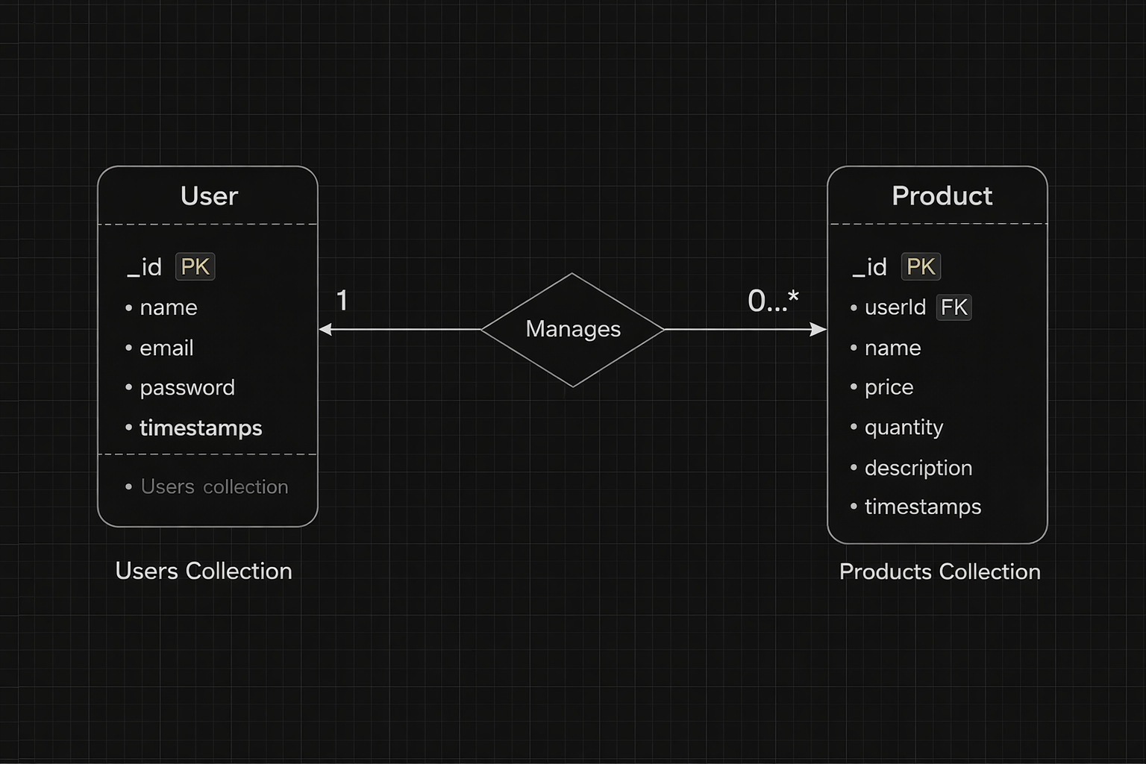

3. SETUP INSTRUCTIONS
3.1.Prerequisites:
Before setting up AI FAQ Assistant ensure that the following tools and technologies are installed on your system:
  - Node.js – JavaScript runtime environment.
  - MongoDB – Database for storing user data, projects, and chat messages.
  - Git – For cloning and version control.
  - Express.js – Backend framework for handling APIs and server logic.
  - Mongoose – ODM (Object Data Modeling) library for MongoDB.
  - Visual Studio Code – Recommended IDE for development.

3.2.Installation steps

3.2.1.Node.js
- Knowledge: basic JavaScript (variables, functions, promises/async-await), basic command-line use (terminal / PowerShell), JSON, and git (recommended).
- System: Windows / macOS / Linux (x64 or arm64); 2GB+ RAM recommended; internet to download installers.
- Tools to have ready: a terminal (CMD/PowerShell/WSL on Windows, Terminal on macOS/Linux), a code editor (VS Code recommended).

Step-by-step installation
Windows — easiest: official installer (or use npm-windows for version management)
Official installer (quick)

- Visit the official Node.js downloads page and download the Windows .msi (choose the LTS build).
- Run the MSI and accept defaults (it will install node and npm and add to PATH).
- Open PowerShell or Command Prompt and verify:
node -v
npm -v
you’re done. nodejs.org

If you want multiple Node versions / safer global installs — use npm for Windows
- Install npm-windows (download and run the installer from the npm-windows releases).
- After install, open a new admin PowerShell or CMD and use:
npm install lts
npm list
npm use <version> # e.g. npm use 18.16.0 OR `npm use lts` if supported
node -v
npm-windows lets you switch versions without re-installers. GitHub+1
npm -v
you’re done.

3.2.2.MongoDB:
  - Knowledge Prerequisites
  - Basic database concepts: collections, documents, CRUD (Create, Read, Update, Delete).
  - Basic command line/terminal usage.
  - JSON knowledge (MongoDB stores data in BSON, similar to JSON).
  - (Optional) Networking basics: ports, IP binding, authentication.
System Prerequisites
  - OS: Windows (x64/arm64 supported).
  - Processor: 64-bit, 1 GHz+ recommended.
  - RAM: Minimum 2 GB (4 GB+ recommended for dev; higher for prod).
  - Disk space: At least 5–10 GB free (MongoDB stores large amounts of data).
  - Port: MongoDB runs on 27017 by default (make sure it’s free/unblocked).
Software Prerequisites
  - Administrator (to install packages/services).
  - Package manager (apt, yum, Homebrew) OR direct installer.
  - MongoDB Shell (mongosh) – required to interact with MongoDB.
  - MongoDB Compass (GUI) – optional but recommended for beginners.
  - Docker (optional) – for containerized setup.
3.2.3.Git
System prerequisites
  - OS: Windows
  - Permissions: Administrator (Windows)
  - Network: Internet access (for cloning/pushing remote repos like GitHub, GitLab, Bitbucket).
Software prerequisites
  - Text/code editor (VS Code recommended).
  - SSH client (optional, for GitHub/GitLab SSH connections).
Github account creation:

1. Sign in to GitHub
- Go to GitHub.
- Log in to your GitHub account. If you don't have one, you can sign up for free.

2. Create a New Repository
- Once logged in, click on the + icon in the top right corner of the page.
- Select "New repository" from the dropdown menu.

3. Fill in Repository Details
You'll need to fill out the following fields:
- Repository Name: Choose a name for your repository (e.g., my-project).
- Description (optional): Provide a brief description of your project (e.g., "A cool web app").
- Public or Private: Choose whether your repository will be public (anyone can see it) or private (only you and collaborators can access it).
- Initialize with README: If you want to add a README file (which is helpful for explaining your project), check this box.
- Add .gitignore (optional): You can choose a template for your .gitignore file, depending on your project's language or framework (e.g., Python, Node, etc.).
- Choose a License (optional): You can choose a license if you'd like to specify how others can use your code.

4. Create the Repository
- Once you've filled everything out, click the Create repository button.

5. Clone the Repository (Optional)
- After the repository is created, you'll be taken to the new repository's page.
- To clone it to your local machine, copy the clone URL (either HTTPS or SSH) from the "Code" button.
- In your terminal, run the following command:
- git clone<repository-url>

6. Start Adding Files
- Now you can start adding files to your repository either through the GitHub website or by pushing files from your local machine.
That's it! You've created a new GitHub repository. Let me know if you need help with the next steps, like pushing files to GitHub.

3.2.4.Express.js – Mongoose – Visual Studio Code
  - Prerequisites (Theory)
  - JavaScript & Node.js → needed since Express runs on Node.
  - MongoDB knowledge → Mongoose is an ODM for MongoDB.
  - REST API concepts → to design routes/endpoints.
  - Visual Studio Code → editor to write and manage the project.
  - Node.js & npm installed → to run server and install packages.
  - MongoDB installed or Atlas account → for database.

- Installation Steps:
# Clone the repository git clone
# Install client dependencies cd client npm install
# Install server dependencies cd
../server npm install
#Install server dependencies cd
../server npm run dev
4.FEATURES

4.1.Core Features:
S.No | Feature | Description
1 | User Authentication | JWT-based register and login system
2 | Question CRUD | Add, view, update and delete questions
3 | Private Data Access | Users access only their own questions
4 | Question Search | Search questions by name
5 | Secure API | Middleware protected routes

4.2.Roles and Responsibility
4.2.1.User
- Registration: Register using name, email and password
- Login: Login using registered credentials
- Add question: Create question with question, answer and category
- Edit Answer: Update existing FAQ answer
- Delete question: Remove FAQ questions
- Search question: Search FAQ qustions
4.2.3.User Flow
- The user sends a register/login request.
- The backend generates a JWT token.
- The user sends a token in the Authorization header.
- Middleware verifies the token.
- The controller performs CRUD operations.
- MongoDB stores or retrieves question data.
- API sends response.

5.FOLDER STRUCTURE

server/
│
├── node_modules/
├── src/
│ ├── controllers/
│ ├── db/
│ ├── middlewares/
│ ├── models/
│ ├── routes/
│ └── server.js
│
├── .env
├── .gitignore
├── package-lock.json
└── package.json

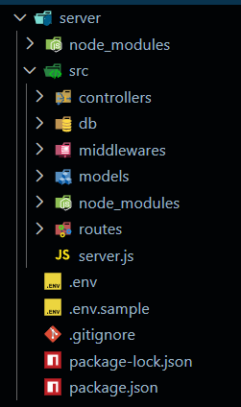
5.1.Initialize Node.js Project:
Open terminal inside the server folder and run:
npm init -y
This creates the package.json file which manages project dependencies.

5.2.Install Required Packages:
Install backend dependencies:
npm install express mongoose cors dotenv jsonwebtoken bcryptjs

Package Purpose:
- express → Backend framework
- mongoose → MongoDB connection
- cors → Cross-origin requests
- dotenv → Environment variables
- jsonwebtoken → Authentication
- bcryptjs → Password hashing

5.3.Create Environment File:
Create a .env file in the root of the server folder.
Example:

PORT=5000
MONGO_URI=your_mongodb_connection_string
JWT_SECRET=your_secret_key

Backend Development

5.4.Setup Express Server:
Inside src/server.js, create the basic Express server.

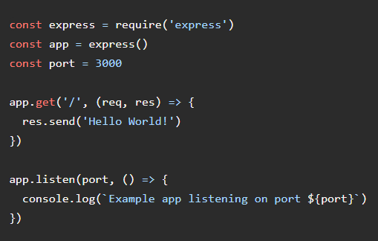

5.5.Create Controllers:
Inside: src/controllers/
Create:
auth.controller.js

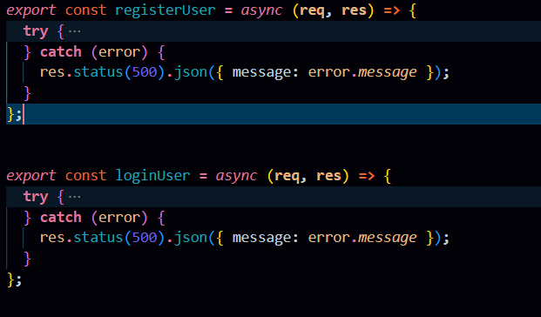
5.6.Create Routes
Inside: src/routes/
Create:
auth.routes.js
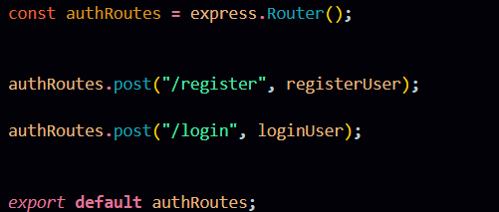

5.7.Auth Routes:
Auth routes handle user authentication by providing endpoints for registration and login. These routes connect incoming requests to the Auth Controller to create new users and generate JWT tokens for secure access.
question.routes.js

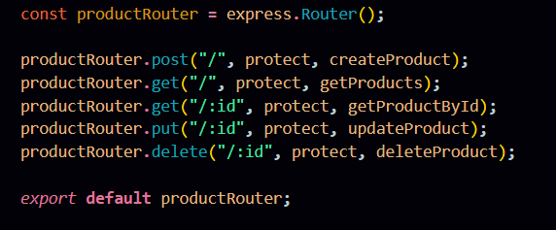
5.8.Question Routes:
Question routes manage all faq assistant-related operations such as creating, retrieving, updating, and deleting questions. These routes are protected using authentication middleware to ensure only authorized users can access their own question data.

Connect Routes to Server
Import all routes into server.js

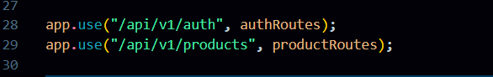
These route configurations connect the authentication and question APIs to the main Express server using versioned endpoints. The /api/v1/auth path handles all user authentication requests, while /api/v1/questions manages question-related operations, helping maintain a structured and scalable API architecture.
Database Configuration and Setup
- Create MongoDB Atlas cluster
- Add connection string to .env
- Connect DB before API testing.
Database Connection:
Create a file inside: src/db/db.js
Purpose: Connect backend to MongoDB using mongoose.
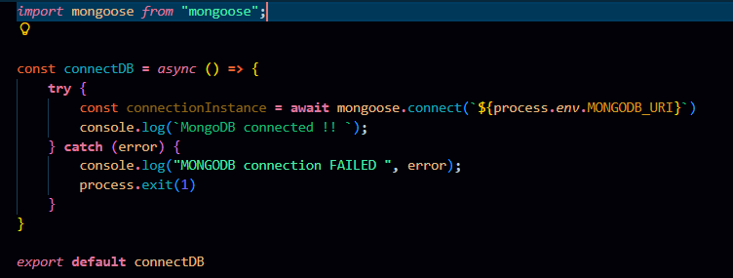

The connectDB function establishes a connection between the application and MongoDB using Mongoose and environment-based configuration. It ensures the server starts only after a successful database connection and logs an error message if the connection fails.
5.9.Create Models:
Inside src/models/ create:
- User.js
- Question.js

User Model:
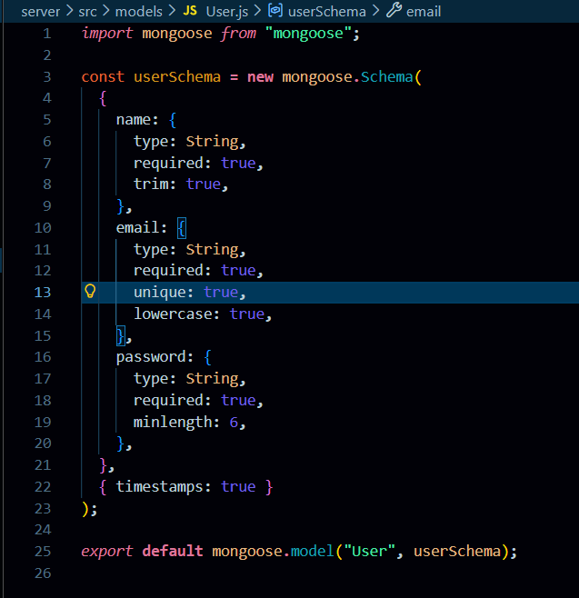

5.10.User Schema:
The User schema defines the structure for storing user details such as name, email, and hashed password in the database. It supports secure authentication and maintains timestamps for record tracking.
Question Model:
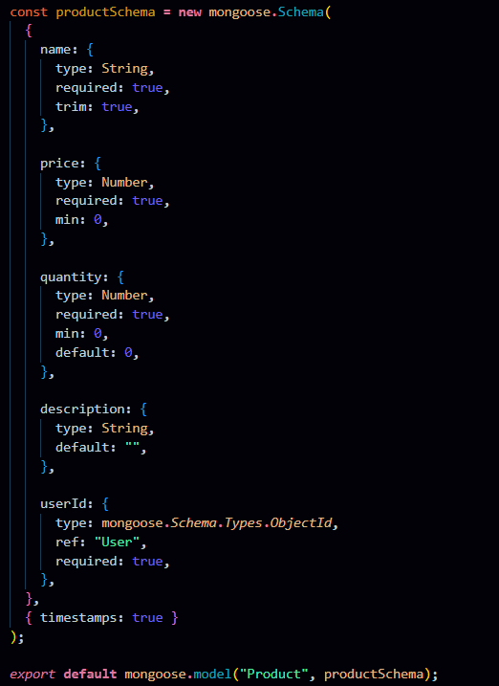

Question Schema:
The Question schema represents faq assistant items and includes fields like name, price, quantity, description, and a userId reference. It ensures each question is linked to its owner, enabling private data access and management.

5.11Use Thunder Client to test APIs:
Test APIs:
5.11.1.Register User:

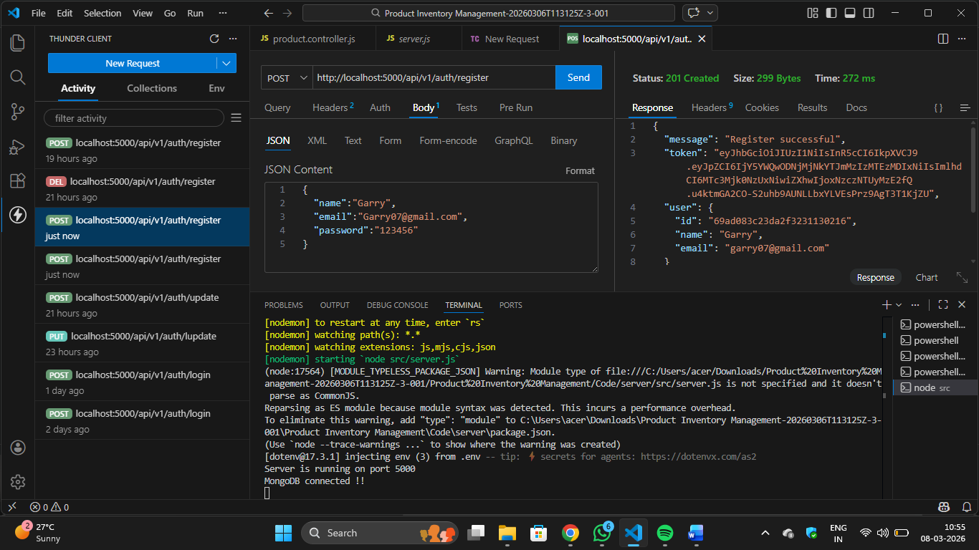
Register:
The register functionality allows new users to create an account by submitting their details, which are validated and securely stored with a hashed password. It ensures unique user creation before granting access to the system.

5.11.2.login user: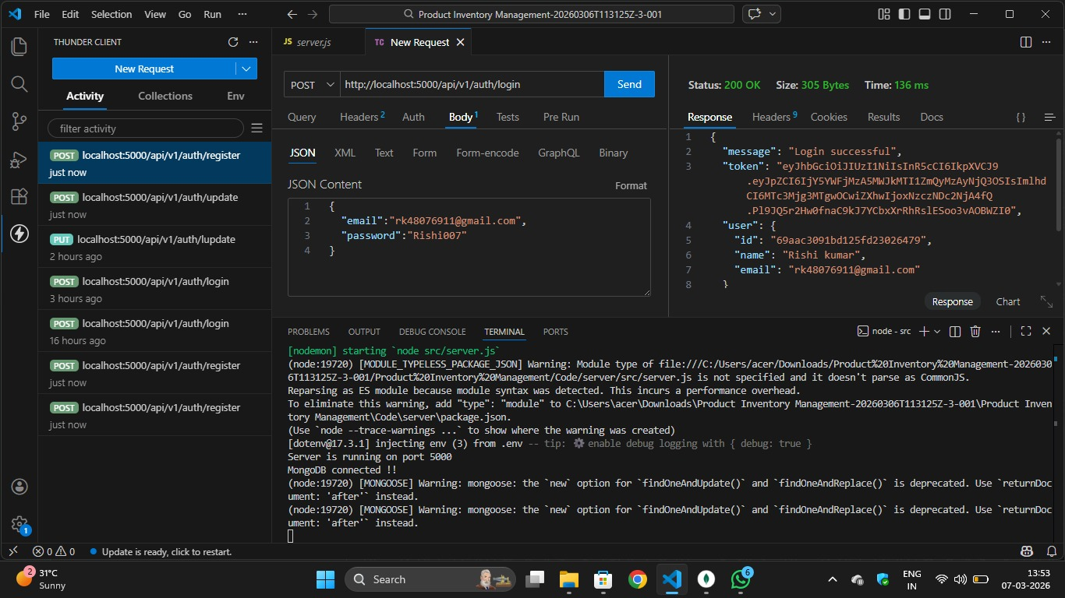
Login:
The login functionality verifies user credentials and generates a JWT token upon successful authentication. This token is used to access protected routes securely.
5.11.3. Create Question
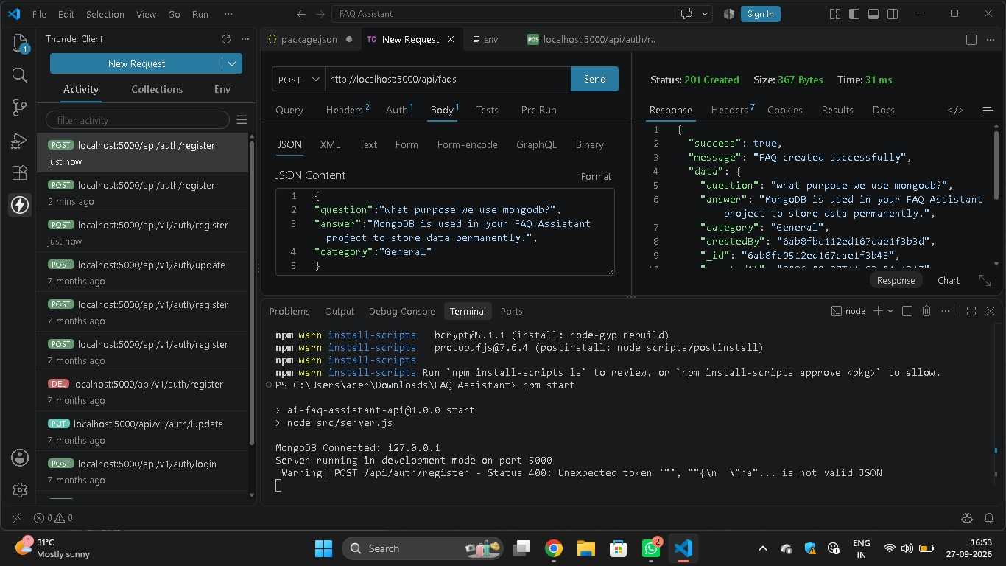
Create question:
Allows an authenticated user to add a new question to their faq assistant by submitting question details.
5.11.6. Delete question:
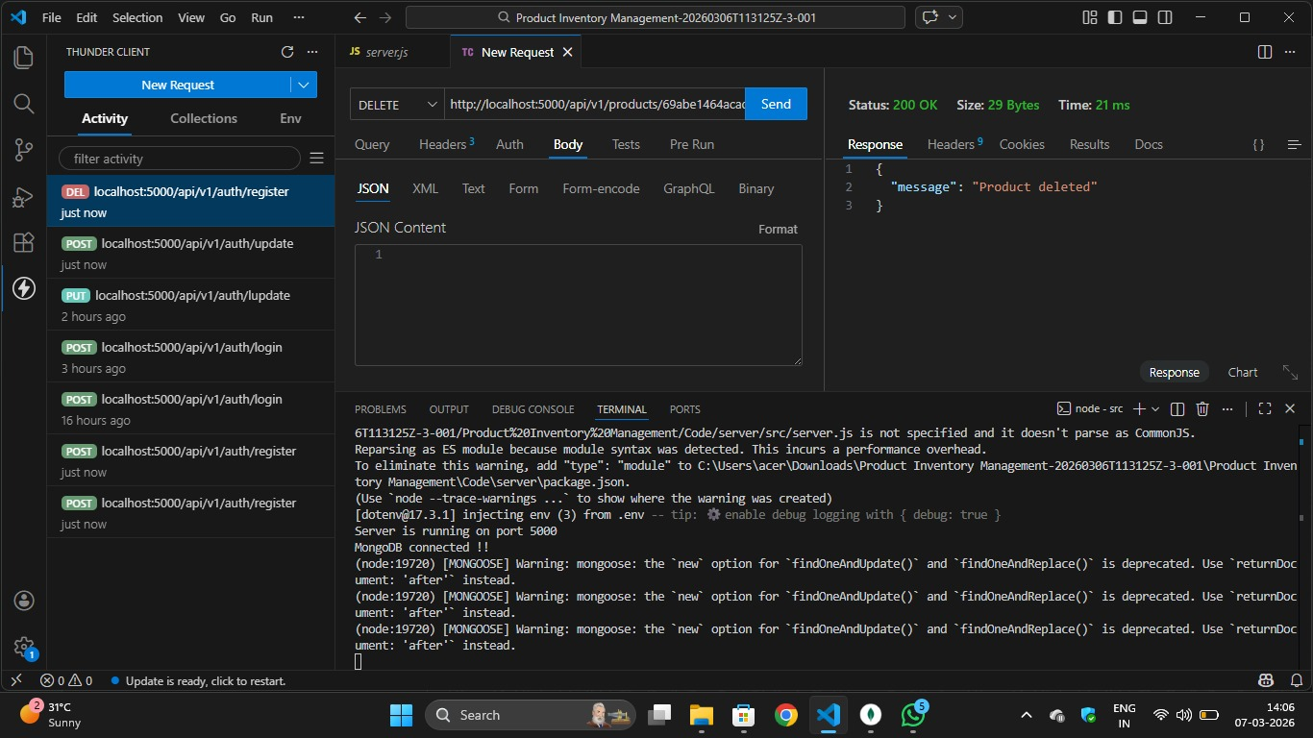
Delete question:
Allows users to permanently remove a question from their faq assistant. The operation is protected to ensure only the question owner can delete it.

5.11.7.MongoDB Compass:
